**Windows 10 UWP – Hands on Lab**

**Lab 5:**

**Note**: This demo app created for this lab uses the Visual Studio 2015 RTM and Windows Tools SDK ver 10240.

1. Open the \ViewModels\BBQRecipeViewModels.cs file and add the following lines of code to line 19.

public DelegateCommand ShareCommand { get; private set; }

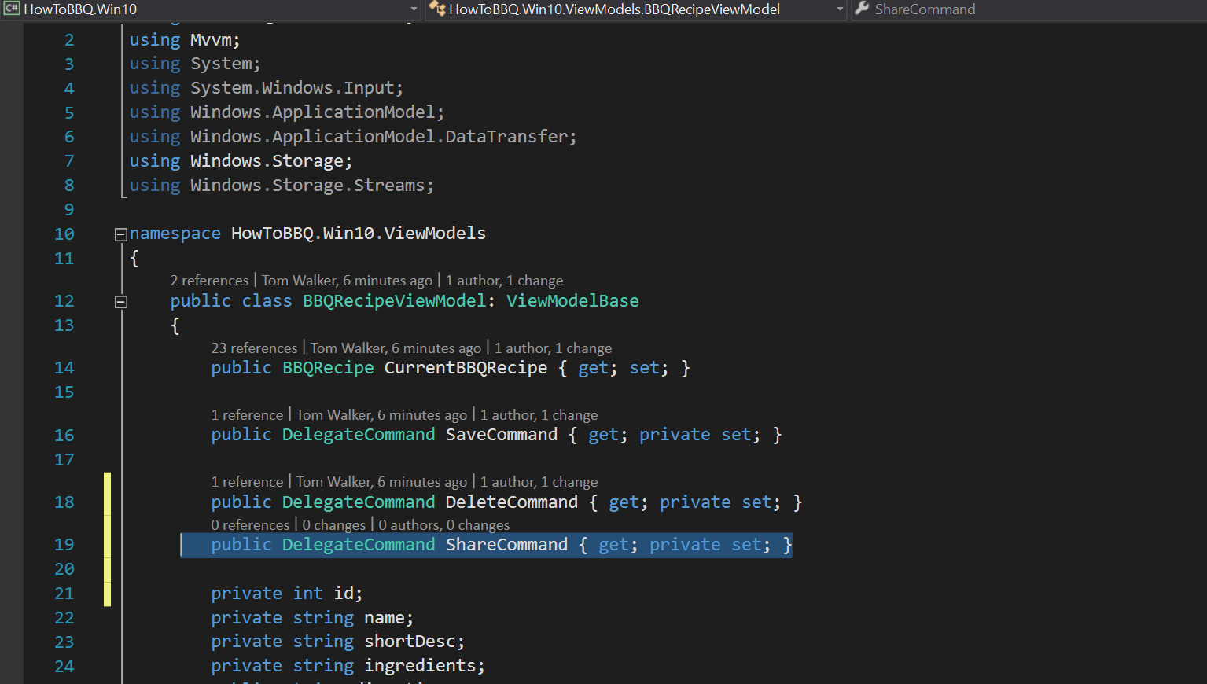

1. In the \ViewModels\BBQRecipeViewModels.cs file and add the following lines of code to line 57.

ShareCommand = new DelegateCommand(ShareBBQRecipe);

DataTransferManager dataTransferManager =

DataTransferManager.GetForCurrentView();

dataTransferManager.DataRequested += DataTransferManager_DataRequested;

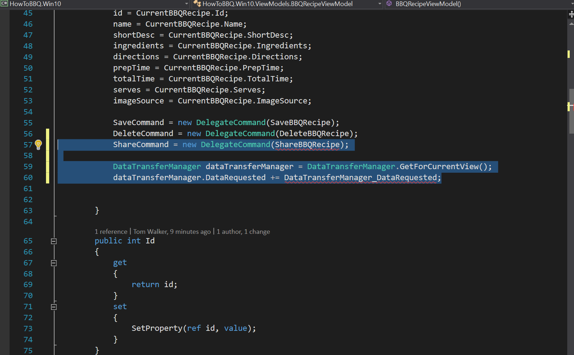

1. In the \ViewModels\BBQRecipeViewModels.cs file and add the following lines of code to line 220

public void ShareBBQRecipe()

{

if (id > 0)

{

DataTransferManager.ShowShareUI();

}

}

private async void DataTransferManager_DataRequested(DataTransferManager

sender, DataRequestedEventArgs args)

{

DataRequestDeferral deferral = args.Request.GetDeferral();

args.Request.Data.Properties.Title = Name;

args.Request.Data.SetText(shortDesc);

var uri = new Uri(imageSource, UriKind.Absolute);

StorageFile storageFile = await

Windows.Storage.StorageFile.GetFileFromApplicationUriAsync(uri);

args.Request.Data.SetBitmap(RandomAccessStreamReference.CreateFromFile(storageFile

));

deferral.Complete();

}

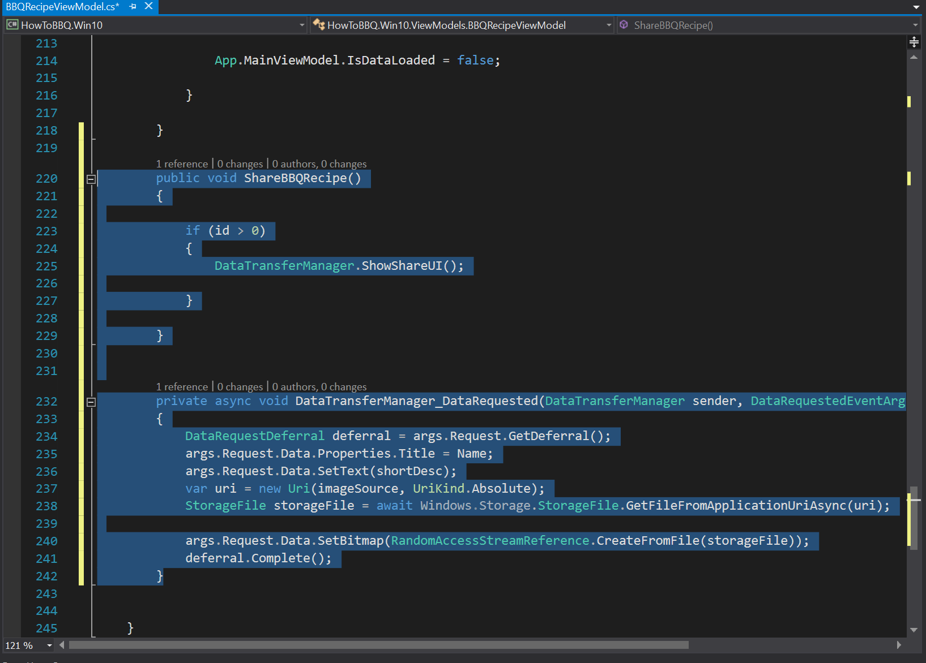

1. Open the \Views\BBQRecipePage.xaml file and make sure the following lines of xaml code are located on line 111.

<Button Margin="10" x:Name="ButtonShare" Content="Share" FontSize="32"

Command="{Binding ShareCommand}">

<Button.Background>

<LinearGradientBrush EndPoint="0.5,1"

StartPoint="0.5,0">

<GradientStop Color="#FFC681F2" Offset="0.171"/>

<GradientStop Color="#FF0A0A0A"/>

<GradientStop Color="#FF0A0A0A" Offset="0.98"/>

<GradientStop Color="#FFC681F2" Offset="0.949"/>

</LinearGradientBrush>

</Button.Background>

</Button>

